### **Task Description**

Develop a chessboard game using React and Redux where each square alternates between white and black. When a white square is clicked, it changes its color to yellow, and when a black square is clicked, it changes to red.

### **Task Output Screenshot**

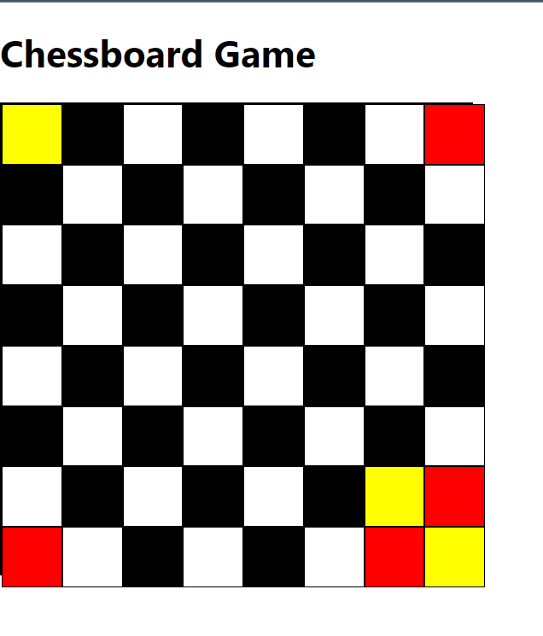

### **Widget/Algorithm Used in Task**

* **Redux**: Used for managing the state of the chessboard, including the colors of the squares.
* **React Components**: The chessboard is created using functional components in React, rendering an 8x8 grid of squares.
* **CSS**: Used to define the initial color of the squares (alternating black and white) and apply the color changes upon clicking.
* **Event Handling**: An onClick event is attached to each square. Based on the color of the square at the time of the click, it changes to either yellow (for white) or red (for black).
* **useState and useDispatch Hooks**: useState is used to maintain the current state of individual squares, and useDispatch is employed to trigger Redux actions that modify the board state.